**Project 4 Part 2 Report**

# Team members

Dafei Du 9328-7153

Yuhao Shi 1707-3591

1. **Basic Requirements: Finished**
2. **Introduction**

We have Program.fs and index.html in this project.

We use suave to implement this project. Here is the reference: <https://github.com/SuaveIO/suave/blob/master/examples/WebSocket/Program.fs>

1. **Compile**

First, input “dotnet run” to compile the code.

Copy 127.0.0.1:8080 and paste this in your browser (chrome) and then you will see the Twitter Simulation interface.

1. **Functionalities**

* **Register**

You should create your username and password, then click sign up button. Once your account is registered successfully, terminal will send you feedback.

You are allowed to register multiple accounts.

* **Login**

After you register an account, you can login. Make sure you input correct username and password, otherwise, you will get a warning.

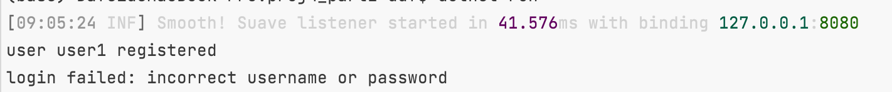

Once you login your account successfully, you can explore more functionalities.

* **Subscriptions**

Input a valid username to subscribe.

* **Send Tweet**

Write some words in text box and click send button. You’ll get the tweet showing below.

* **Search Tweet**

You can search tweets by typing tag or any key word.

* **Retweet**

Input another valid username to retweet.

